**EC2 Instance**

**Step1-** To create a Ec2 instance, firstly go to your AWS console management, search for EC2 instance, then at left side go to instance & click launch instance.

Make sure you connect a specific region.

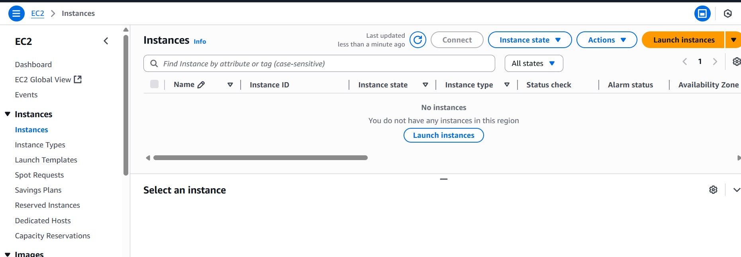

**Step 2-** Once you clicked on launch instance you will see this kind of page fill all the related information as per your requirements. Under the Name & tags = we need to put specific name that should be unique one.

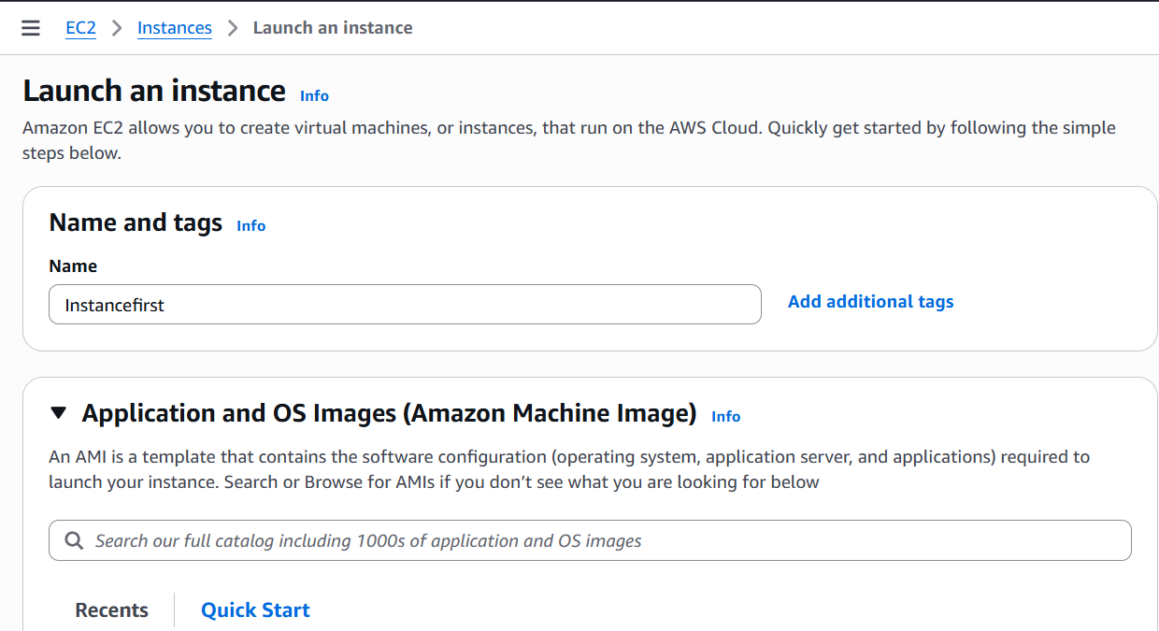

**Step 3 –** Then select your AMI (Amazon Machine image). It contains the Operating system like Ubuntu etc.

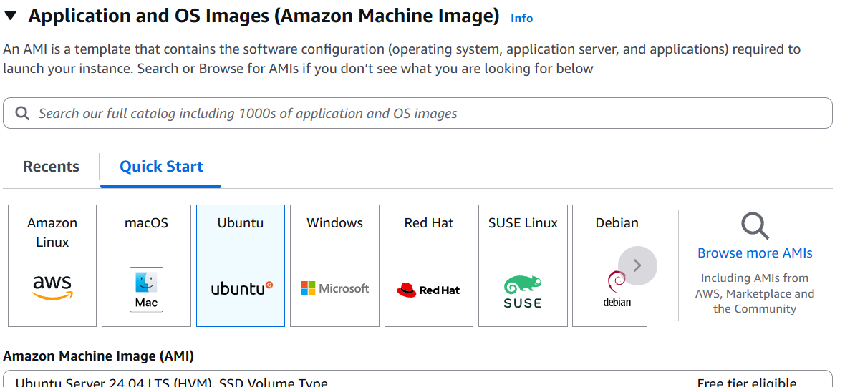

**Step 4 –** Then select your Instance type, which include your project requirement such as CPU, Memory. I used here t2.micro that has 1vCPU, 1GB Memory.

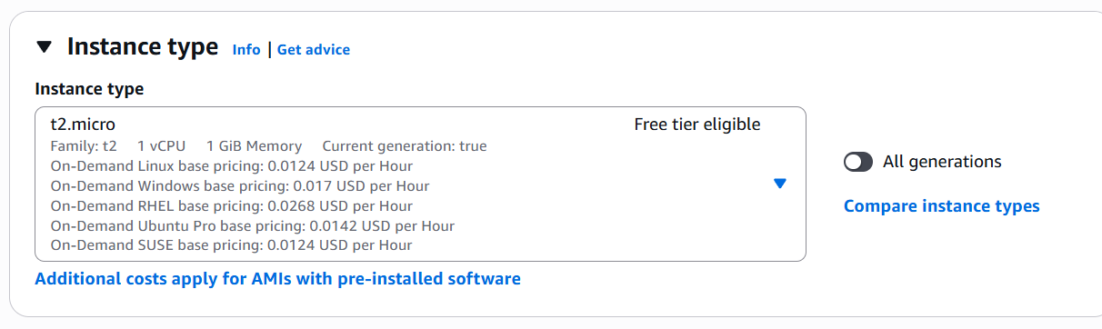

**Step 5 –** Key pair helps you to connect your instance specially for SSH. So that no one can access your instance also you when you generate new key pair public key stored on the Ec2 instance & Private key downloaded in your system.

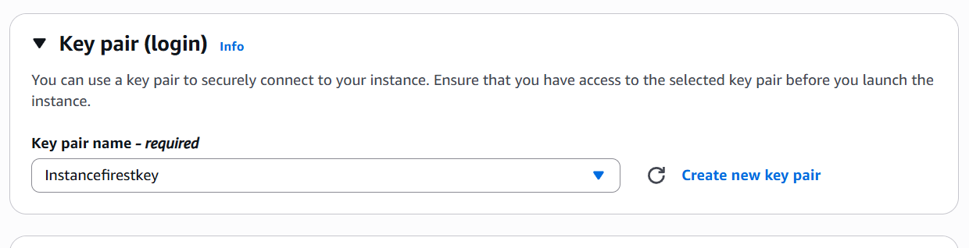

**Step 6-** Choose network security group, and add your IP address so that only you can access it.

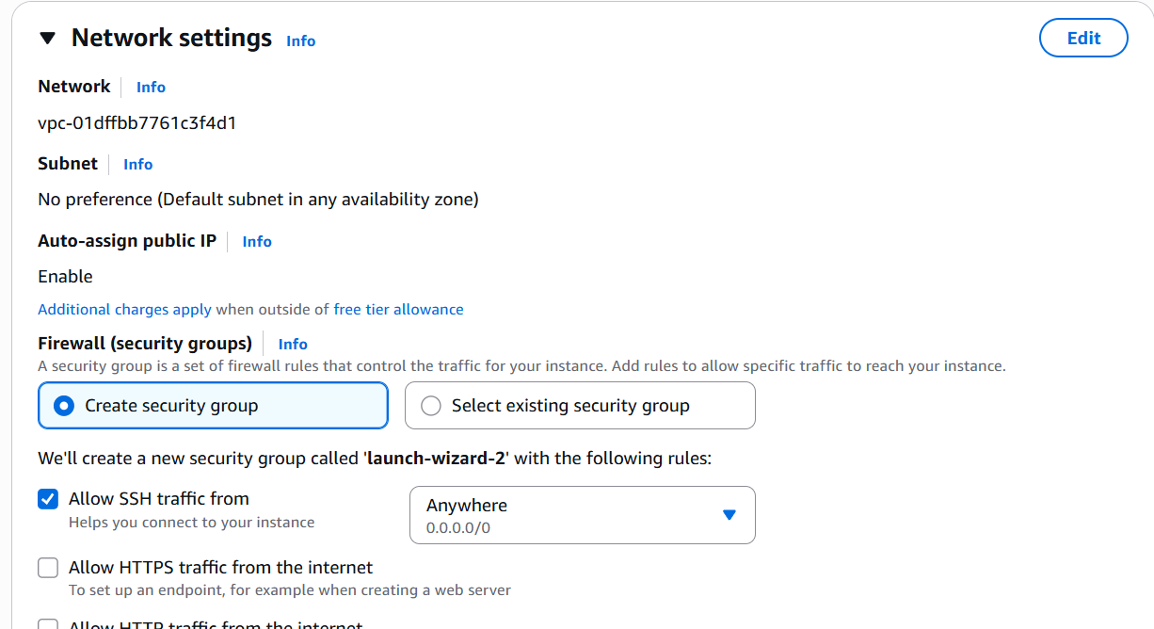

**Step 7-** Then put storage requirement as per project

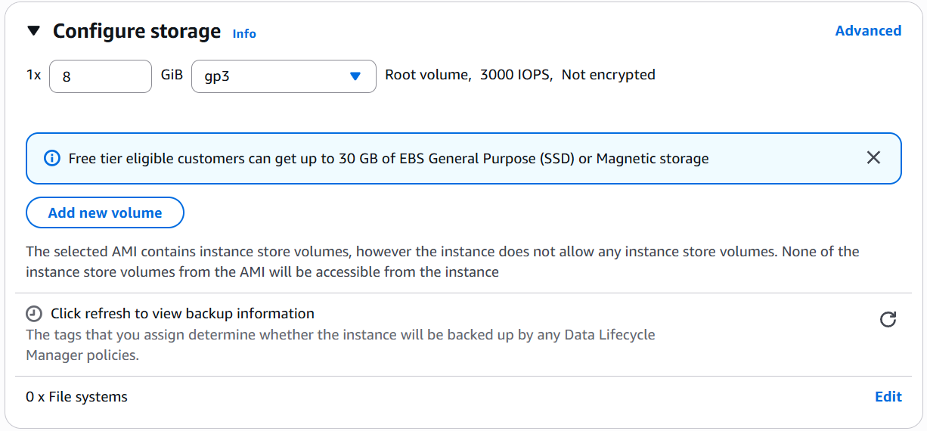

**Step 8 –** Finally click on launch an instance & your instance is created successfully. 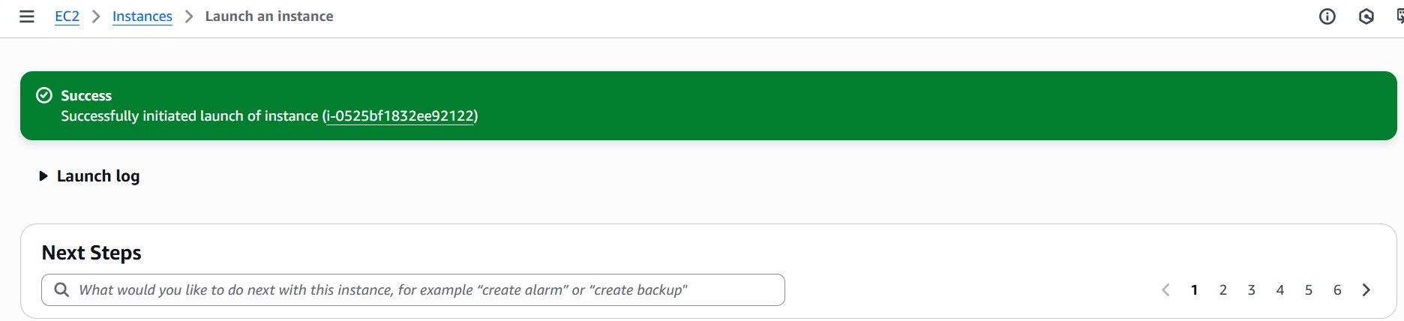

**Step 9 –** Go to EC2 again refresh the page under instances we can see my Instancefirst is on running state.

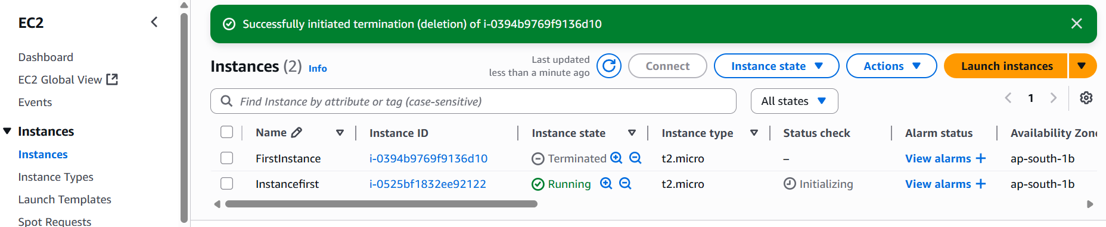

**Step 10-** Now at last press connect & you are able to connect to browser.

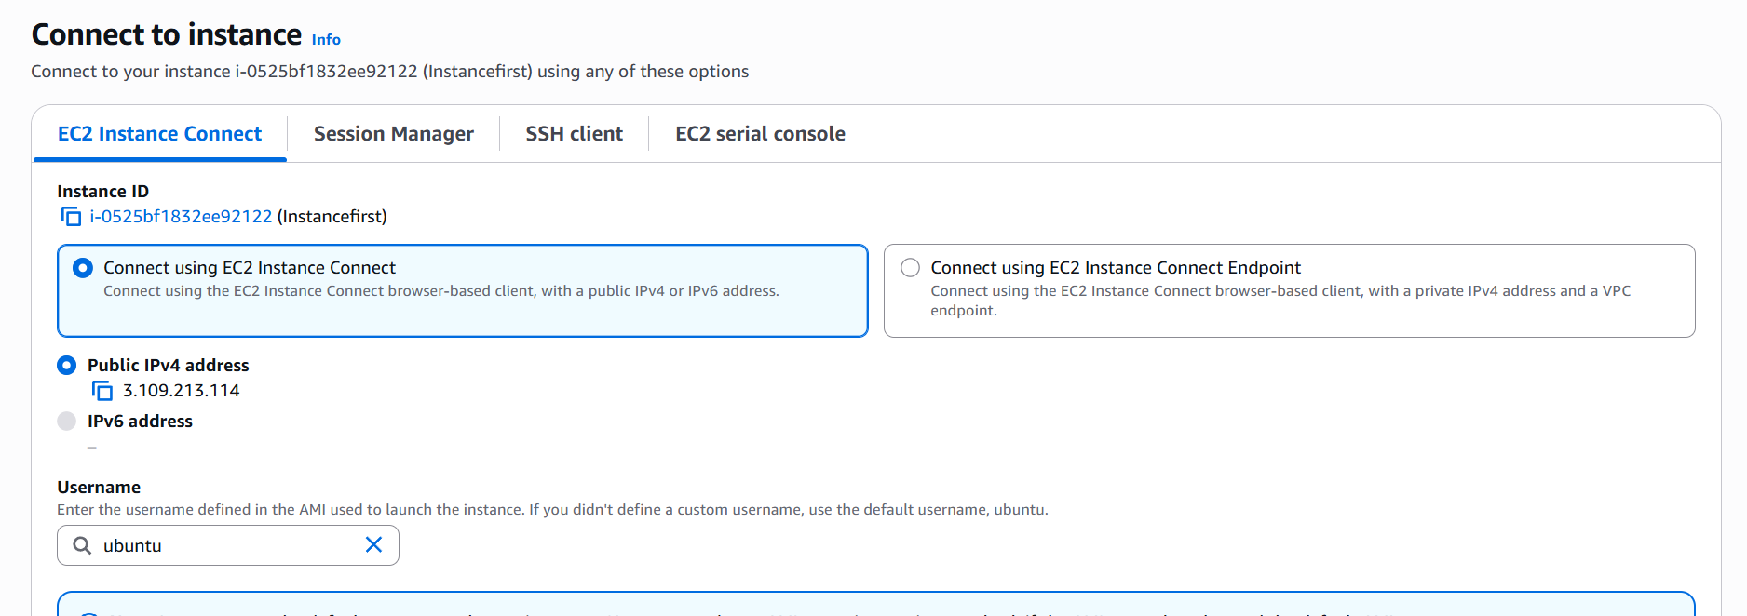

**Step 11-** Here we can put the commands to check whether instance is on working state or not. I try ls & pwd command, successfully able to connect my instance to the browser.

